1)Create new table BusinessentityDetails

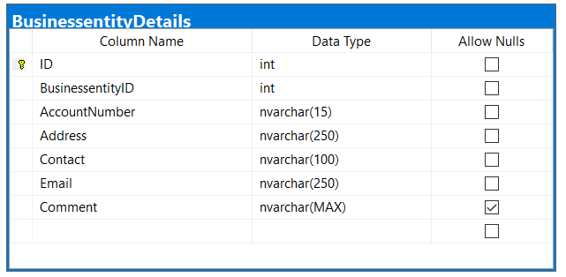

Add foreign key [FK_businessentity_detailsID] that references BusinessEntity.ID

2)Alter the table and add the following constraints:

* UNIQUE constraint on column AccountNumber
* Check constraint on column Email. The constraint should check if the value has format [%@%.%](mailto:%25@%25.%25)
* Check constraint on column Contact. The constraint should check if the first two values begin with 07

3)Insert the following values for the new table

insert into dbo.BusinessentityDetails (BusinessentityID,AccountNumber,[Address],Contact,email,comment)

values(1,'210500222333','Partizanski Odredi 15','070555666','aaa@vitalia.com','Nema zabeleshka')

go

insert into dbo.BusinessentityDetails (BusinessentityID,AccountNumber,[Address],Contact,email,comment)

values(2,'210500222334','XXXX 15','070779523','bbb@vitalia.com',NULL)

go

insert into dbo.BusinessentityDetails (BusinessentityID,AccountNumber,[Address],Contact,email,comment)

values(3,'210500222335','XXXX 16','070779523','ccc@vitalia.com','TEST 1')

go

insert into dbo.BusinessentityDetails (BusinessentityID,AccountNumber,[Address],Contact,email,comment)

values(4,'210500222335','XXXX 17','070779523','dddvitalia.com',NULL)

go

insert into dbo.BusinessentityDetails (BusinessentityID,AccountNumber,[Address],Contact,email,comment)

values(5,'210500222336','XXXX 18','070779544','vvv@vitaliacom','Nema plateno faktura')

go

insert into dbo.BusinessentityDetails (BusinessentityID,AccountNumber,[Address],Contact,email,comment)

values(6,'210500222337','XXXX 19','070779555','ddd@vitaliacom',NULL)

go

insert into dbo.BusinessentityDetails (BusinessentityID,AccountNumber,[Address],Contact,email,comment)

values(7,'210500222338','XXXX 20','070779566','aa@vitalia.com','Nevaliden kontakt')

go

4)Update column Comment with value: ‘Nema zabeleshka za smetka’

5)Create function dbo.fn_ProductQuantitySold that returns the sum of quantity of products sold, for productid as input parameter.

6) Create function dbo.fn_ProductPriceSold that returns the sum of price of products sold, for productid as input parameter.

7)Create view dbo.vv_report that returns the following columns:

[Регион] – concatenate zipcode and region with – separator

[Број на сметка] – AccountNumber

[Адреса] – replace XXXX with ‘Улица број’

[Име на продукт] – ProductName

[Количина] – Result from function fn_ ProductQuantitySold

[Цена] – Result from function fn_ProductPriceSold